Supplementary material
Increasing Stiffness Promotes Pulmonary Retention of Ligand-Directed Dexamethasone-Loaded Nanoparticle for Enhanced Acute Lung InflammationTherapy

Yinglan Yu, Shujie Li, Yuan Yao, Xinran Shen, Lian Li, Yuan Huang*

Key Laboratory of Drug-Targeting and Drug Delivery System of the Education Ministry and Sichuan Province, Sichuan Engineering Laboratory for Plant-Sourced Drug and Sichuan Research Center for Drug Precision Industrial Technology, West China School of Pharmacy, Sichuan University, Chengdu 610041, China.
* Corresponding Author
Yuan Huang, E-mail: huangyuan0@163.com, Tel/Fax: +86 2885501617.

1. Materials and methods
1.1 Materials
Poly (lactic-co-glycolic acid) (PLGA, lactide: glycolide = 50/50) with one methoxyl end group was purchased from Lactel Absorbable Polymers (Birmingham, UK). Soybean phospholipid (SPC) was purchased from Shanghai Taiwei Pharmaceutical Co., Ltd (Shanghai, China). Cholesterol was obtained from Chengdu Xiya Chemical Co., Ltd. (Chengdu, Sichuan, China). 1,2-distearoyl-sn-glycero-3-phosphoethanolamine-N-[methoxy(polyethylene glycol)-2000] (DSPE-PEG₂₀₀₀) was purchased from AVT (Shanghai) Pharmaceutical Tech Co., Ltd. (Shanghai, China). DSPE-PEG₂₀₀₀-NHS was purchased from Shanghai Ponsure Biotechnology Co., Ltd. (Shanghai, China). FcBP (Arg-Phe-Pen-Thr-Gly-His-Phe-Gly-Sar-NMeLeu-Tyr-Pro-Cys, Mw1512.32) was synthesized by Shanghai Apeptide Co., Ltd. (Shanghai, China). Dexamethasone (Dex) was purchased by Shanghai Yuanye Biotechnology Co., Ltd. (Shanghai, China). Pluronic F68 (F68), coumarin 6 (C6) and lipopolysaccharides (LPS, Escherichia coli O55:B5) were offered by Sigma-Aldrich Corporation (St. Louis, Missouri, USA). Reactive oxygen species assay kit, 1,10-Dioctadecyl-3,3,3',3'-tetramethylindotricarbocyanine iodide (DiR), 4’,6-diamidino-2-phenylindole (DAPI), ER-Tracker Red, and Golgi-Tracker Red were provided by Beyotime Biotechnology Inc (Shanghai, China). TNF-α ELISA kit was purchased from Quanzhou Ruixin Biological Technology Co., Ltd. (Quanzhou, China). Rabbit anti-FCGRT/FCRN and rabbit anti-Rab5 were bought from Abcam (Cambridge, UK). Goat anti-rabbit IgG/Alexa Fluor 647 was obtained from Beijing Boison Biotechnology Co., Ltd. (Beijing, China). All other chemicals and reagents in the study were analytical grade.

1.2 Cells cultures
The human lung adenocarcinoma cells (Calu-3 cells) were obtained from the Institute of Biochemistry and Cell Biology (Shanghai, China). Cells were cultured in Dulbecco’s modified eagle medium (DMEM, Invitrogen, USA) containing 10% (v/v) fetal bovine serum (FBS, Gibco, USA), 1% (v/v) penicillin and streptomycin solution (100 IU/mL), and 1% (v/v) sodium pyruvate (Beijing Science & Technology Co., Ltd., Beijing, China) at 37°C in an atmosphere with 95% relative humidity and 5% CO₂.

1.3 Animals
Male Sprague-Dawley (SD) rats and ICR mice were provided by Chengdu Dashuo Biological Technology (Chengdu, Sichuan, China). All animal experiments were approved by the Institutional Animal Care and Use Committee of Sichuan University (accreditation number, SYXK (Chuan) 2018-113). Animals were housed in standard cages under optical light, temperature, and humidity conditions, with ad libitum access to water and food. All the animals were acclimatized for one week before further experiments.

1.4 Synthesis of DSPE-PEG₂₀₀₀-FcBP
FcBP was added in the solution of DSPE-PEG₂₀₀₀-NHS in 4 mL N, N-Dimethylformamide (DMF) at the molar ratio of 1.2:1. After adding moderate N-methyl morpholine, the reaction was stirred at room temperature with argon protection for about 36 h. Subsequently, the product was purified by dialysis against 50% ethanol (v/v). The final product was obtained after lyophilization and stored at -20℃. The ¹H Nuclear Magnetic Resonance (¹H NMR) was used to confirm the reaction.

2. Results

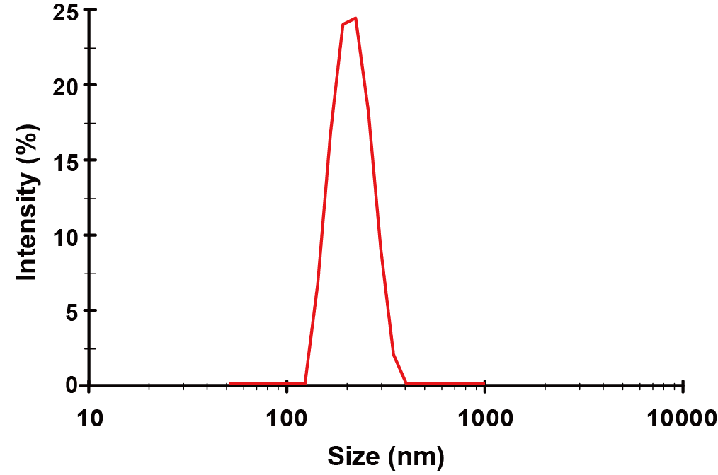
Figure S1. The hydrodynamic diameter of PLGA (15 mg/mL) nanoparticles.

Figure S2. Peak fluorescence intensity of PLGA-lipid NPs.

Figure S3. TEM morphological characterization of NPs.

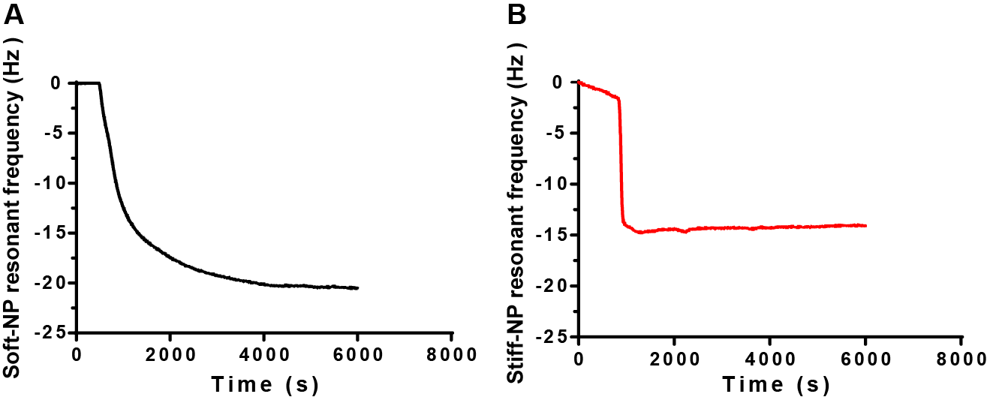
Figure S4. QCM analysis of PLGA-lipid NPs. The resonant frequency of Soft-NP (A) and Stiff-NP (B).
Figure S5. TEM morphological characterization of FcBP-modified NPs.

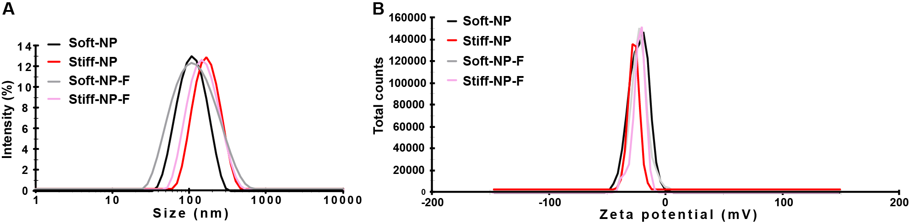
Figure S6. Hydrodynamic diameter (A) and zeta potential (B) of PLGA-lipid NPs by dynamic light scattering (DLS).

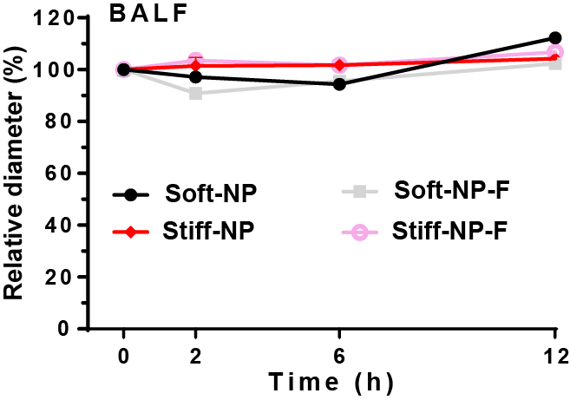
Figure S7. Ex vivo stability of PLGA-lipid NPs in rat bronchoalveolar lavage fluid (BALF) at room temperature for 12 h. Mean ± SD, n = 3.

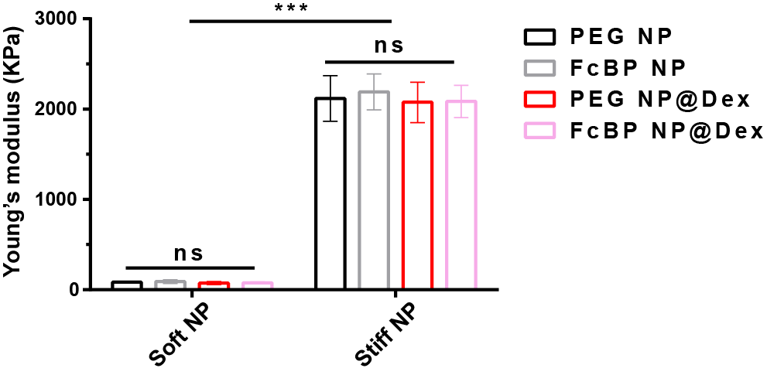
Figure S8. The Young’s modulus of NPs was measured by atomic force microscope. *** p＜0.001, ns p＞0.05. Mean ± SD, n = 3.

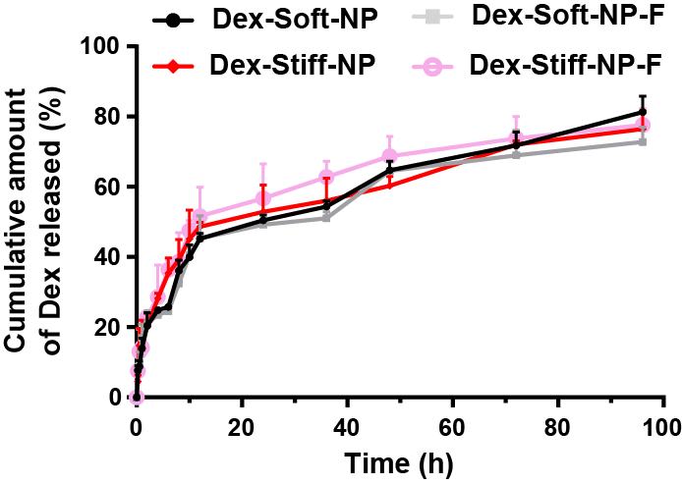
Figure S9. The cumulative amount of Dex released from NPs. Mean ± SD, n = 3.

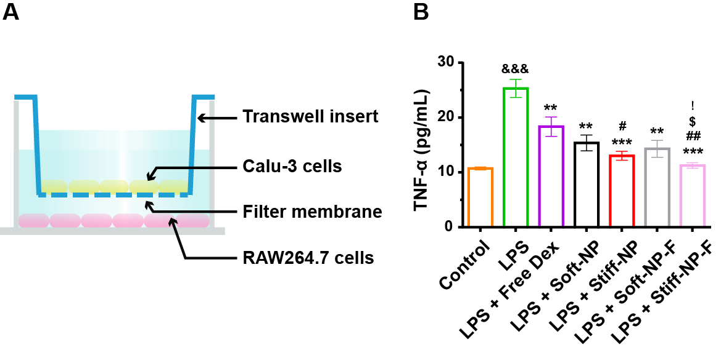
Figure S10. Fabrication and in vitro anti-inflammatory effects of nanoparticles. (A) The schematic graph of the anti-inflammatory study in vitro. (B) TNF-α was measured using ELISA. * p＜0.05, ** p＜0.01, *** p＜0.001 versus LPS; # p＜0.05, ## p＜0.01, versus LPS + Free Dex; $ p＜0.05, versus LPS + Soft-NP; &&& p＜0.001 versus normal; ! p＜0.05 versus Stiff-NP. Mean ± SD, n = 3.

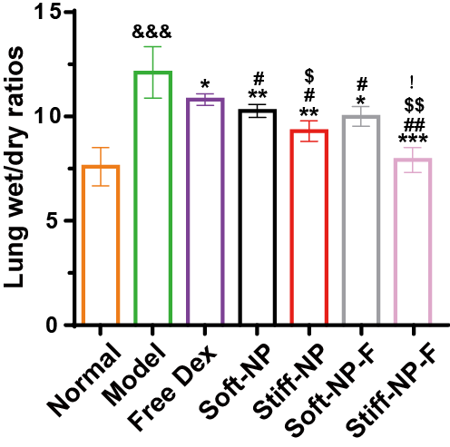
Figure S11. The lung wet-to-dry ratios after treatments. * p＜0.05, ** p＜0.01, *** p＜0.001 versus model group; # p＜0.05, ## p＜0.01, versus free Dex; $ p＜0.05, $$ p＜0.01, versus Soft-NP; &&& p＜0.001 versus normal; ! p＜0.05 versus Stiff-NP. Mean ± SD, n = 6.

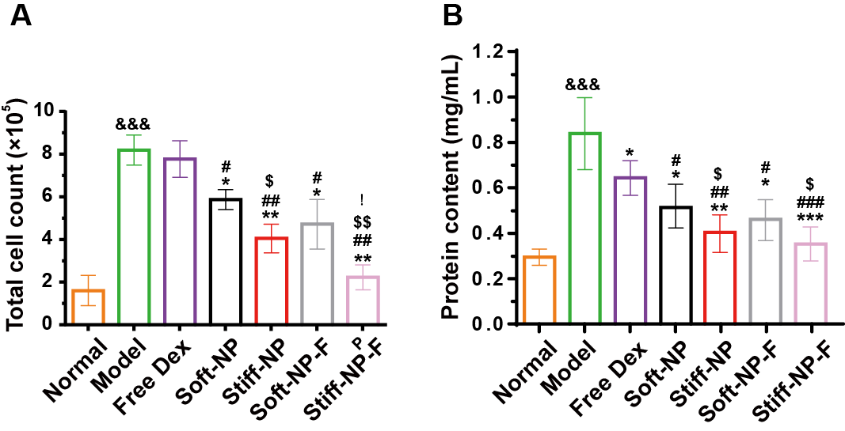
Figure S12. Therapy of acute lung injury (ALI) with NPs in rats. (A) Total cell counts in BALF. (B) Protein contents in BALF were measured using BCA kit. * p＜0.05, ** p＜0.01, *** p＜0.001 versus model group; # p＜0.05, ## p＜0.01, ### p＜0.001 versus free Dex; $ p＜0.05, $$ p＜0.01, versus Soft-NP; &&& p＜0.001 versus normal; ! p＜0.05 versus Stiff-NP. Mean ± SD, n = 6.

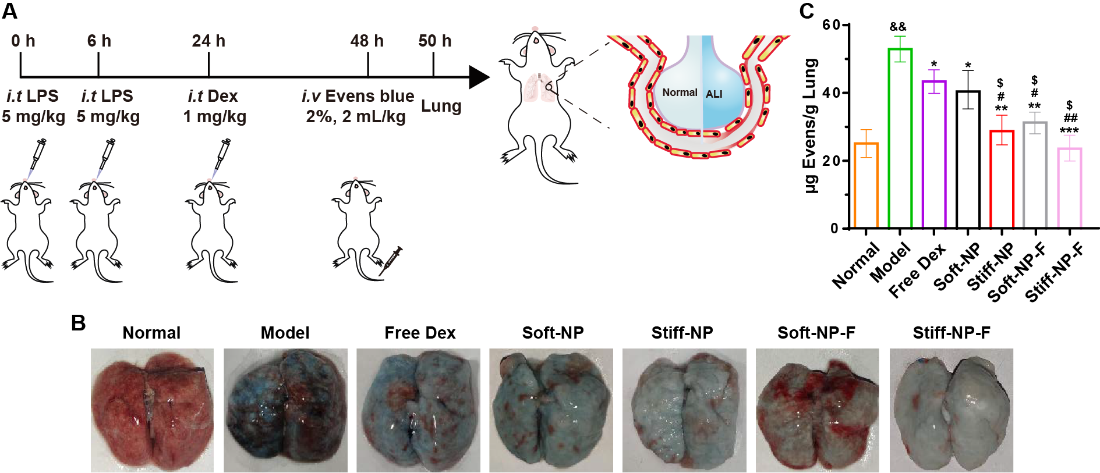
Figure S13. Pulmonary vascular permeability of acute lung injury (ALI) with NPs in rats (A) Experimental protocol of pulmonary vascular permeability study. (B) Representative photographs of the lungs treated with Evans blue. (C) Evans blue amount within the lung. * p＜0.05, ** p＜0.01, *** p＜0.001 versus model group; # p＜0.05, ## p＜0.01, versus free Dex; $ p＜0.05, versus Soft-NP; && p＜0.01 versus normal. Mean ± SD, n = 6.

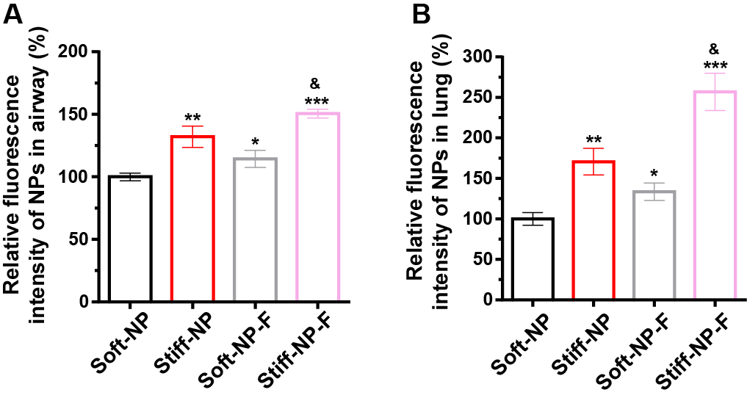
Figure S14. Relative fluorescence intensity of NPs in rat airway (A) and lung (B). * p＜0.05, ** p＜0.01, *** p＜0.001 versus Soft-NP. & p＜0.05 versus Stiff-NP. Mean ± SD, n = 3.

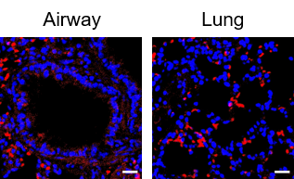
Figure S15. Immunostaining for FcRn in rat airway and lung. Scale bar: 20 μm.

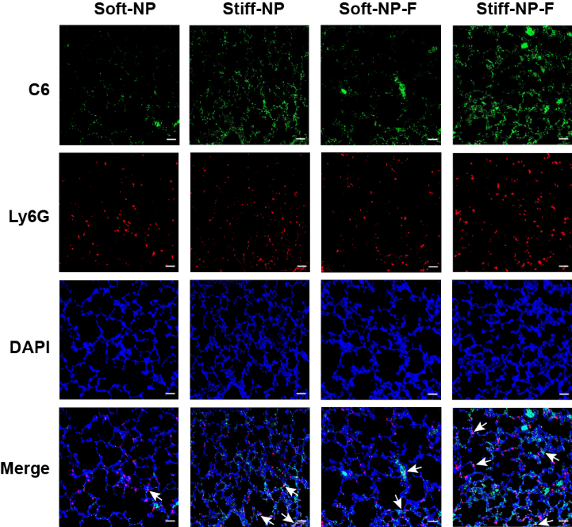
Figure S16. The ALI rat lungs distribution of NPs. Blue: DAPI stained nucleus; green: C6-loaded NPs; red: Ly6G-labeled neutrophils. Scale bar: 50 μm.

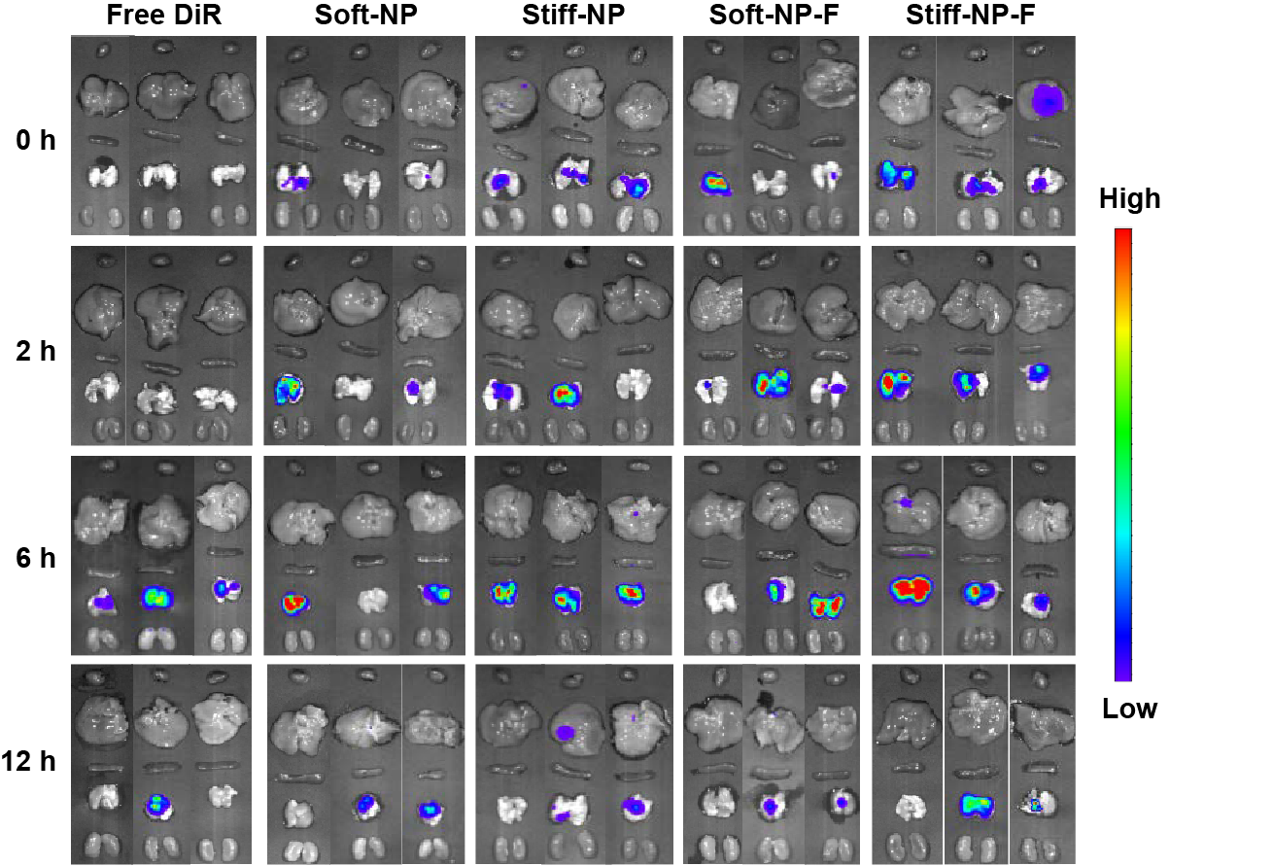
Figure S17. In vivo fate investigation. Representative photographs of the excised heart, liver, spleen, lung, and kidney of mice.

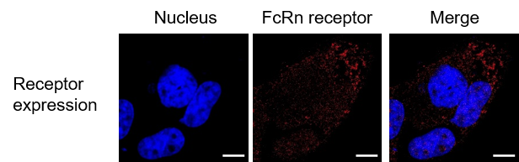
Figure S18. Immunostaining for FcRn in Calu-3 cells. Scale bar: 10 μm.

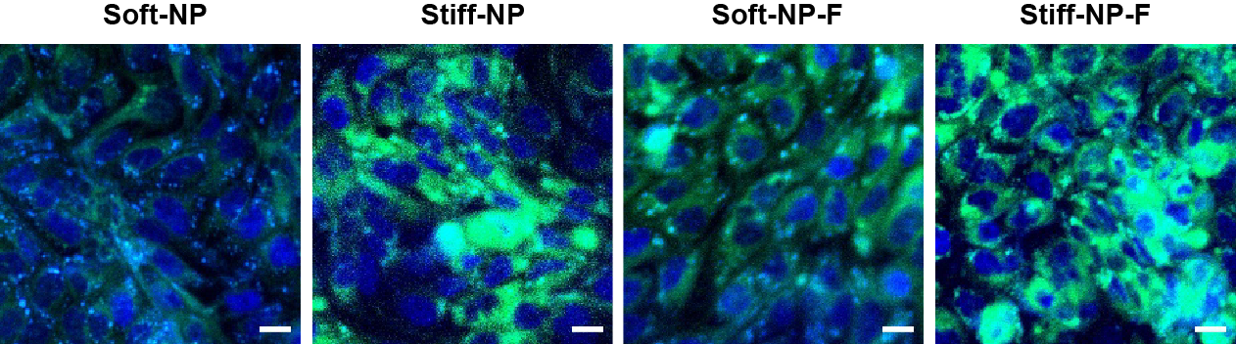
Figure S19. CLSM images of Calu-3 cells after exposure to C6-loaded NPs. Scale bar: 20 μm.

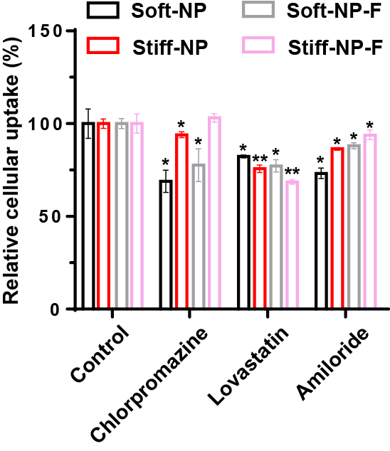
Figure S20. Relative cellular uptake of NPs in cells inhibited by chlorpromazine (clathrin-mediated endocytosis inhibitor), lovastatin (caveolae-mediated endocytosis inhibitor), and amiloride (micropinocytosis inhibitor). * p＜0.05, ** p＜0.01 versus control. Mean ± SD, n = 3.

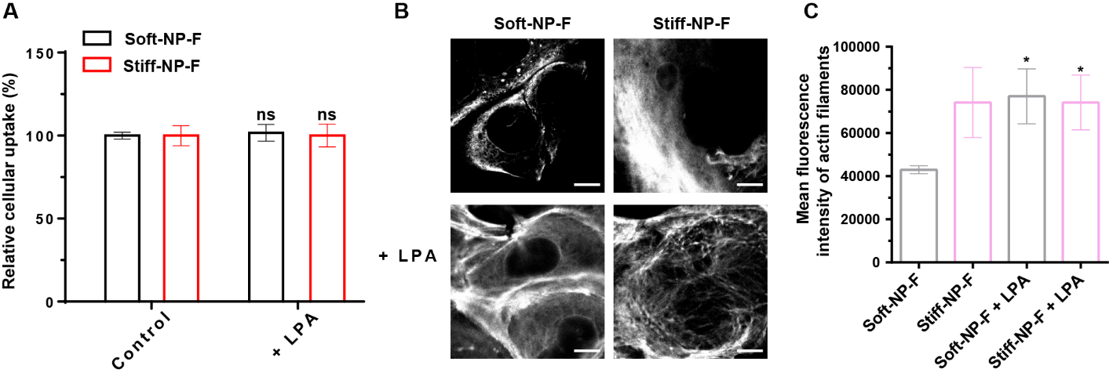
Figure S21. (A) The relative uptake of Calu-3 cells with the LPA. ns, p＞0.05 versus control. (B) Organization of actin filaments following the feeding of FcBP-unmodified PLGA-lipid NPs, with or without the additional incubation with LPA. Scale bar: 10 μm. (C) The quantitative assessment of actin filaments. * p＜0.05 versus NPs without LPA. Mean ± SD, n = 3.

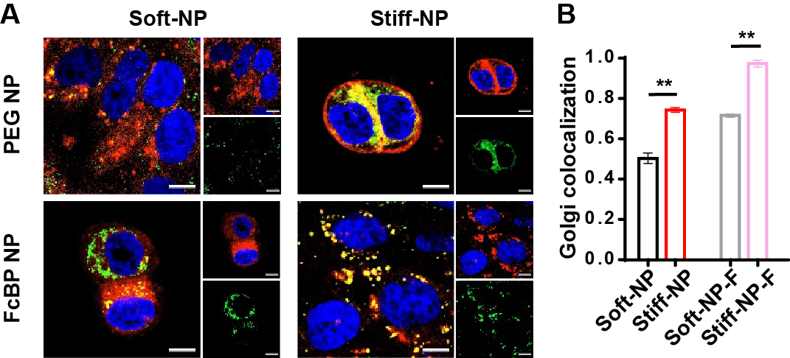
Figure S22. The intracellular trafficking of NPs. The CLSM images (A) and co-localization (B) of NPs with Golgi. Blue: nucleus; red: Golgi; green: NPs. Scale bar: 10 μm. ** p＜0.01, mean ± SD, n = 3.

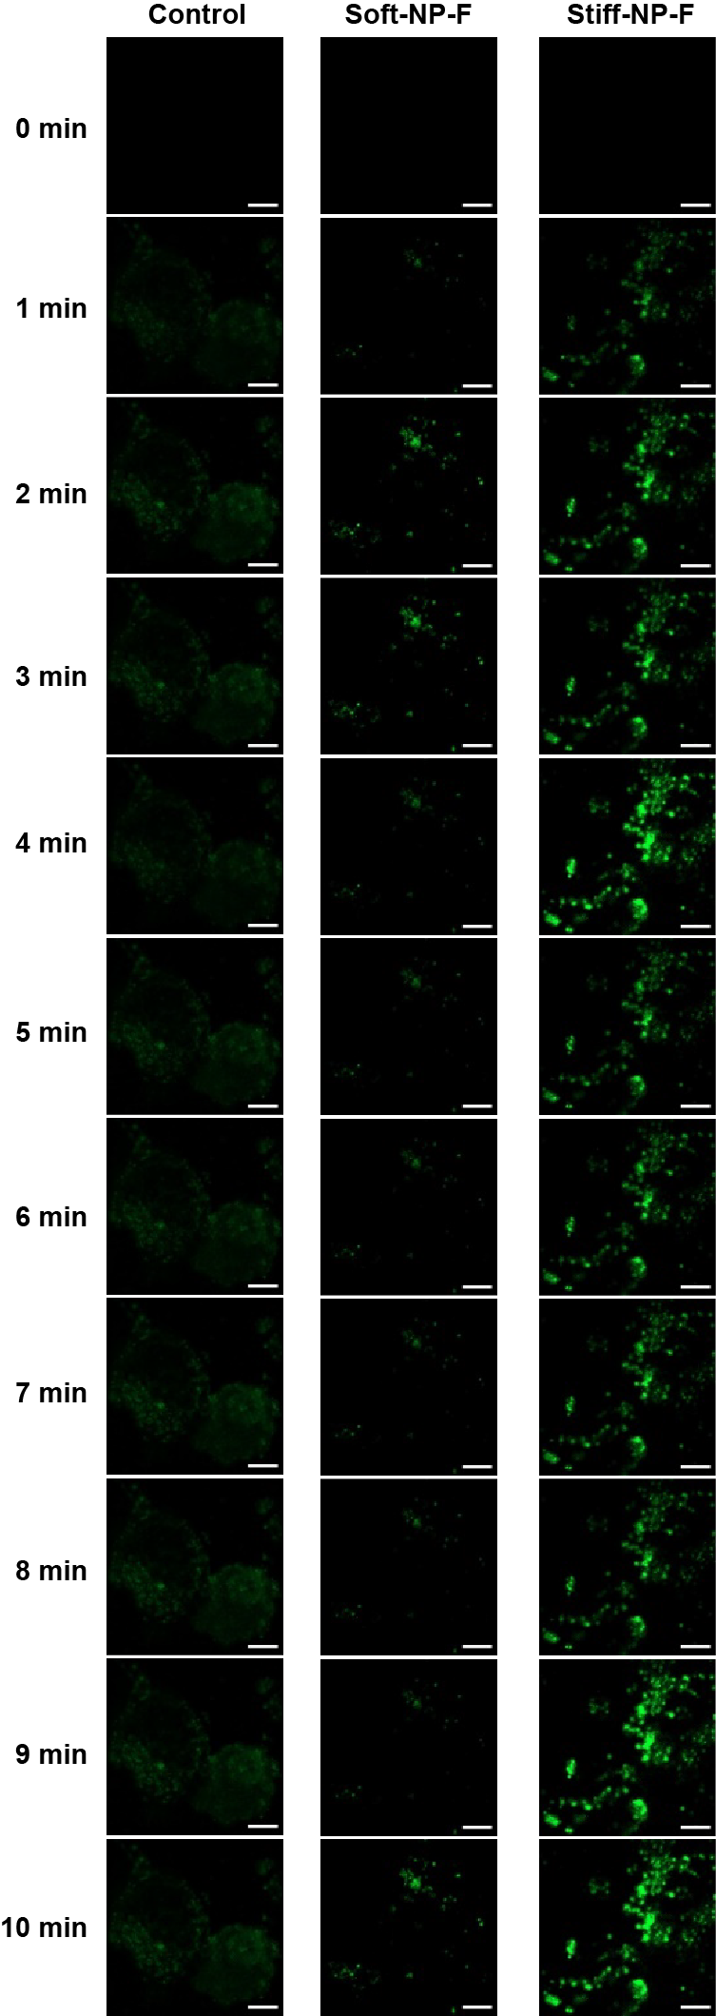
Figure S23. CLSM images of Ca²⁺ in Calu-3 cells during endocytosis of FcBP-modified PLGA-lipid NPs. Control was the group not treated with NPs. Scale bar: 10 μm.

Table S1. The quantification of FcBP decoration. Mean ± SD, n = 3.
 | Soft-NP-F | Stiff-NP-F
FcBP modification rate (%) | 2.25 ± 0.82 | 2.43 ± 0.61

Table S2. Characterization of Dex-loaded NPs. Mean ± SD, n = 3.
Samples | Size (nm) | PDI | Zeta potential (mV) | Encapsulation efficiency (%) | Drug loading (%)
Dex-Soft-NP | 105.5 ± 2.32 | 0.283 ± 0.052 | -23.2 ± 0.89 | 86.32 ± 1.96 | 6.43 ± 0.14
Dex-Stiff-NP | 125.9 ± 2.26 | 0.281 ± 0.028 | -26.1 ± 1.52 | 86.82 ± 2.37 | 6.45 ± 0.21
Dex-Soft-NP-F | 106.5 ± 2.25 | 0.299 ± 0.025 | -24.9 ± 0.96 | 87.38 ± 3.67 | 6.52 ± 0.31
Dex-Stiff-NP-F | 129.2 ± 2.69 | 0.261 ± 0.023 | -23.8 ± 1.36 | 86.92 ± 2.83 | 6.46 ± 0.23

Table S3. The quantification of lung injury score and infiltrating cell count. Mean ± SD, n = 3.
 | Normal | Model | Free Dex | Soft-NP | Stiff-NP | Soft-NP-F | Stiff-NP-F
Lung injury score | 1.3 ± 0.5 | 9.3 ± 0.8&&& | 7.7 ± 1.2 | 5.7 ± 1.3* | 4.1 ± 0.8**# | 4.7 ± 0.9** | 2.3 ± 0.5***#$
Infiltrating cell count | 76.2 ± 10.4 | 390.3 ± 15.4&&& | 337.3 ± 9.4* | 291.3 ± 22.3** | 214.3 ± 24.9**#$ | 253.0 ± 25.5**# | 144.0 ± 8.1***##$$!
* p＜0.05, ** p＜0.01, *** p＜0.001 versus model group; # p＜0.05, ## p＜0.01, versus free Dex; $ p＜0.05, $$ p＜0.01, versus Soft-NP; &&& p＜0.001 versus normal; ! p＜0.05 versus Stiff-NP.

